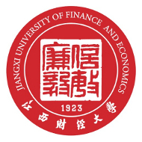

JIANGXI UNIVERSITY OF FINANCE & ECONOMICS

