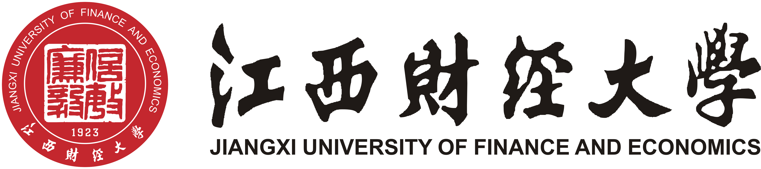

PREGRADUATION CERTIFICATE

This is to certify that Zhang San, Gender: female, born on -----, has been studying in the general full-time Postgraduate Program majoring in International Business in School of International Trade And Economics of Jiangxi University of Finance and Economics since September, 2021. The duration of the study is four years. Upon completion of all required credits and fulfillment of graduation requirements, She will graduate at June, 2025.

Graduate School
Jiangxi University of Finance and Economics

